THE FIRST ENGLISH
E N I G M A
MAGAZINE IN OUR TOWN
M A G A Z I N E 
Š U R A N Y
---------------------------------------------------------------------------

Would you like to improve your English by reading?
The answer is: READ ENIGMA MAGAZINE

Would you like to get news what´s happening in Šurany and its surroundings?
The answer is: READ ENIGMA MAGAZINE

Would you like to have fun in your free time?
The answer is: READ ENIGMA MAGAZINE

…ENIGMA MAGAZINE is now here for you!

Enigma Language School is going to publish monthly magazine in electronic form with a lot of info, jokes, crosswords, presentations, pictures, articles, tasks, photos…

---------------------------------------------------------------------------
1 - June 2011

CONTENT:

COVER PAGE: Presentation of new English magazine in Šurany
PAGE 01: Content
PAGE 02: Hurray Summer is coming…
PAGE 03: Spring in Enigma Language School
PAGE 04: Spring in our town Šurany
PAGE 05: Spring in our town Šurany
PAGE 06: Spring in the world
PAGE 07: Travelling
PAGE 08: The smallest kids´ page
PAGE 09: Young reders´ page
PAGE 10: Teens´ page

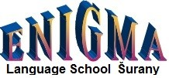

__________________________________________________________
1
HURRAY SUMMER IS COMING…
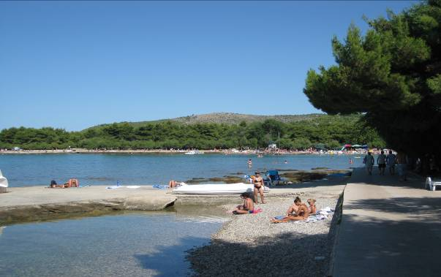

We are looking forward to spend beautiful time in the next coming up summer holiday. People like going to the swimming pools, by the sea, to the camps. Kids love water, they play a lot of games, have a lot of fun.
….anyway we can advise you how to spend suuny days in Šurany and its surroundings.
Enigma Language School organizes HAPPY SUMMER CAMP for kids of our school. The camp is for week form 18.7.2011 - 22.7.2011. We start every day at 8.00 and finish at 16.30. We use English for about 5 hours/day. The children are going to visit different places around Šurany.They are going to meet some interesting people, to have a lot of fun, to do many activities, to compete a lot, to see animals to have barbecues…

Except this camp we prepare for you:

1. Intensive course for beginners
2. Intesive course for children
3. Intensive course for “MATURITA STUDENTS”
__________________________________________________________
2

S P R I N G I N E N I G M A

However we started to talk about summer we were really happy that hopefully spring came after the long winter months…

…the nature woke up and our children were cheering in sunny days. We started to have lessons in our beautiful garden. We played games, had competitions, were stretching, doing exercises, dancing, listening to songs and singing.

As well we celebrated EASTER HOLIDAYS together. Enigma Language School prepared chocolate eggs, bunnies and other sweets and we hided them under the trees, bushes and plants in our garden. The children were looking after them, the smallest kids with the helpof their parents and the others alone.

They had a lot of fun at the lesson. You can probably imagine what a happiness was seen in each eye of the children! They really enjoyed this lesson as they parents said.

The rest of the lesson the childenwere playing games, having fun….of course in ENGLISH! At the end of the lesson each child received except chocolate eggs and bunny well looked home baked presentof Easter bunny from one parent of Enigma In this way we THANK once again.

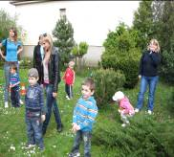
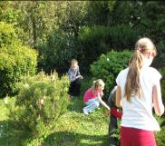
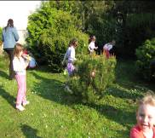
Here are some of the photos from Easter Days in Enigma.
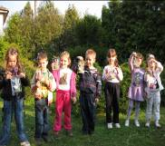
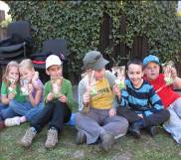
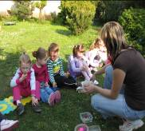

__________________________________________________________
3
S P R I N G I N Š U R A N Y

GENERAL INFORMATION

After long winter days our town tided up all the dust in the main streets in the town. Our inhabitants cleaned the mess in front of their houses, they switched the dust in the street forwards their homes. Hovever it wasn´t everything, workers started to built new park and park area in front of Poliklinika.

In the part of Nitriansky Hrádok volunteers mostly fishermen cut dry branches and tided the mess along the river Nitra.

The most Christian people celebrated Easter Holidays in church on Easter Friday.There were more services in all Christian churches in Šurany. On Easter Monday some people still prefer traditional Easter. They decorated their houses, boys went to pour girls, then the girls gave them chocolate or decorative eggs…and sometimes boys receive money from their mothers, grandmothers, aunts, cousins. The other people preferred relax in the nature or they were traveling somewhere for this holidays.

For young people the new entertainment place was opened. It is situated in the centre of our town and it is called ROTUNDA.

As far as we are informed the new street full of modern family houses is going to be built soon in Cintorínska street in our town.

CULTURAL EVENTS

The Teachers´ day

Every year on 28th March teachers celebrate this holiday in Slovakia. The teachers of all primary schools and kindrekertens had a celebration in Disco Hall in Šurany. The Major of the town was invited there and he appreciated and congratulated to the teachers who got award for their long and patient work at school. Nowadays teaching is difficult and exhausted job. it takes a lot of energy and and time to teachers, they are not financially awarded as they should be…but if there is one who decides to do this job, he or she definitely loves children and youth. The teachers realize that they have to educate and to teach to behave the next generation. THANKS to all the teachers for their work!

The Day of Daffodils - 18th April

The town Šurany took part in the collection for The Ligue Against Cancer. This year it was 15th year of collectingmoney in the streets of our town too. Šurany and its surrounding collected 2.585,50 euro. GREAT THANK TO ALL WHO GAVE MONEY!

__________________________________________________________
4

The Evening before 1st May

There was the town event in Zora Centrum The Major of the town had a speech to the inhibitants, then town musical band Tamburáši entertaint people.

1st May in Šurany

On that day there were two importants events in Šurany The first one was the HORSE RACE COMPETITION and the second one was THE FISHING COMPETITION in Štrkáreň. Lots of people were watching these two events, even media reported them Young families with their children spent their free time together and enjoyed this weekend. Older inhabitants liked these two events, too.

SPORT EVENTS

Our town Bedminton team won the ligue. After seven years of practicing badminton the team thinks about entering to the 1st Bedminton ligue in Slovakia.

__________________________________________________________
5

S P R I N G I N T H E W O R L D

Royal Wedding

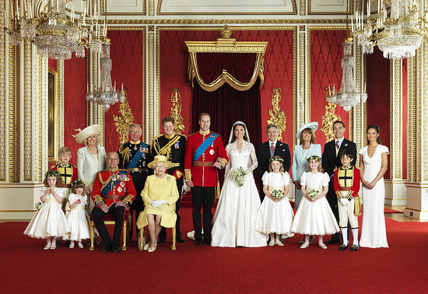
The Duke and Duchess of Cambridge, Prince William and Kate Middleton, posed with their immediate families and wedding party for this official portraits in the throne room at Buckingham Palace yesterday. The photos were taken by Hugo Burnand and included in the picture from left to right in the front, Miss Grace van Cutsem, Miss Eliza Lopes, her majesty The Queen, The Hon. Margarita Armstrong-Jones, Lady Louise Windsor, and Master William Lowther-Pinkerton. In the back, Master Tom Pettifer, HRH Camilla, Duchess of Cornwall, Prince Charles, Prince of Wales, HRH Prince Harry of Wales, Michael Middleton, Michael Middleton, James Middleton, and Philippa Middleton. It was a day full of celebrations for the newlyweds, who exchanged their I dos in a morning ceremony, followed by their receptions. This morning, Kate and William were whisked away by helicopter to a secret weekend destination, though it's not their official honeymoon just yet. In case you missed any of the action yesterday, check out all the best royal wedding pictures and the most gorgeous moments of Kate Middleton's wedding dresses!
View Slideshow ›

Source: Getty

__________________________________________________________
6

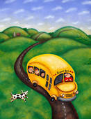
T R A V E L L I N G

Hovever Enigma language school is at the beginning of its existence we all realize that learning English means for everyone the open gate to the world. We are persuaded that early English learning is the best way how to be prepared for understanding nowadays world throughout the Internet and other media and definetly traveling is also great experience how to practice language in some way. Travelling provides getting knowledge about other places, towns and countries. It provides practicing ENGLISH in real situations.

Enigma Language School therefore decided to organize various trips for learners and their families. We think that the time they spend together has a great value for both children and parents.

During this spring we visited the capital of Hungary - Budapest. We spend wonderful time in famous tropicarium. Children were amazed by different fish, alligators, sharks and other sea animals. After observing Tropicarium some children with their parents spend time in fun fairs on roundabouts. Others went to have a rest outside of McDonalds´ were they had “fast lunch” too. The weather was perfect, the sun wes shinning all day. At 6.15p.m. we arrived to Šurany tired but full of beautiful experiences.

Here are some photos:

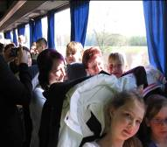
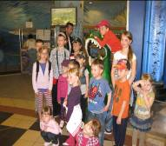
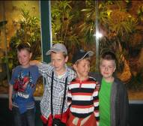
__________________________________________________________
7

The Smallest Kids´ Page

1. Count the numbers!

…………. sweets …………cars

2. Colour the picture!

red bed blue sofa

3. Finish my body!


- blue eyes
- orange nose
- red mouth
- small ears
- green arms
- yellow legs

__________________________________________________________
8

Young Learners´ Page

1. Colour the pictures!

red ship blue plane green car

2. Count the numbers!

………… apples ………… bananas ………..sweets

3. Colour the house and the garden!

__________________________________________________________
9
Teens´ page

1. Shopping items - match them together!

1. ham, chicken, meat a/ book shop
2. medicine and tablets b/ newsagent´s
3. books, CDs´ c/ butcher´s
4. toys, games d/ chemist´s
5. slippers, shoes e/ toy shop
6. newspaper, magazine f/ shoe shop

2. Name these things!

_____________ _____________ ____________ ____________

3. Household activities - write them to the correct box!

wash the windows, hang out the clothes, tidy up, wash the clothes, do the shopping, wash the car, dust the furniture, feed the dog, put away the books, take the dog for a walk, make the bed, water the flower, shovel the snow, iron clothes, mop the floor

INDOORS | OUTDOORS

__________________________________________________________
10
BYE - BYE

SEE YOU THE NEXT MONTH!

